**-- 📊 Business Insight Queries – Urban Noise Analytics**

**-- Query 1: Top 5 Noisiest Areas**

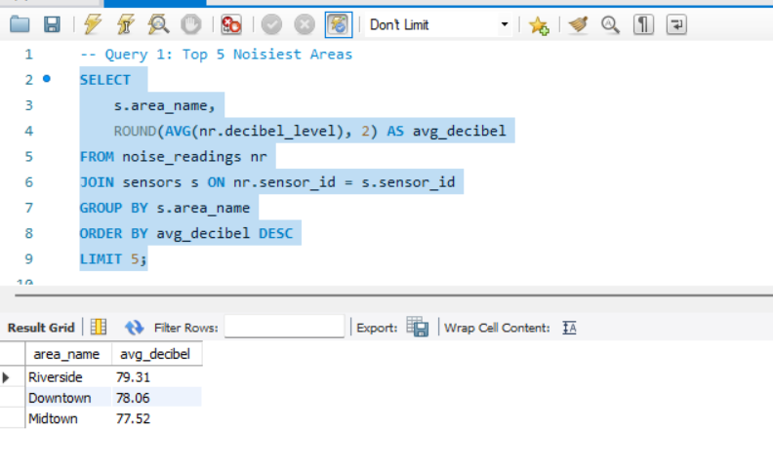

**-- Query 2: Daily Noise Trends**

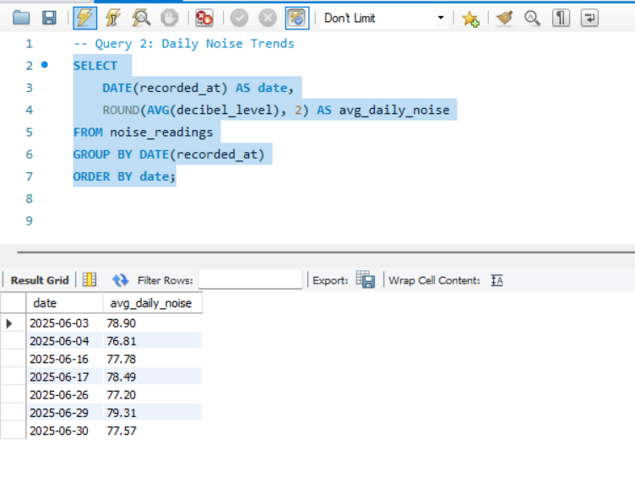

**-- Query 3: Event Day Noise Impact**

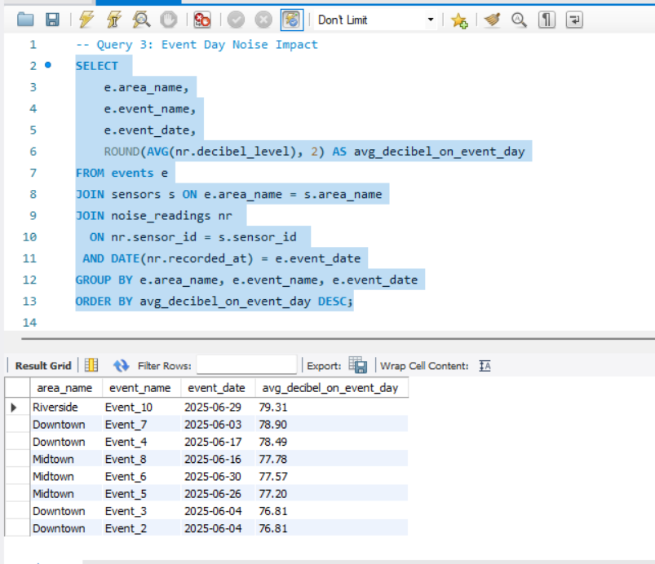

**-- Query 4: Top 5 Busiest Sensors**

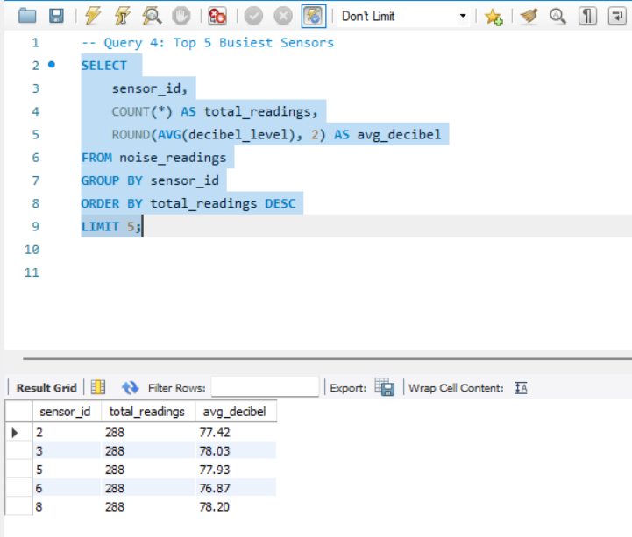

**-- Query 5: Noise Category Distribution**

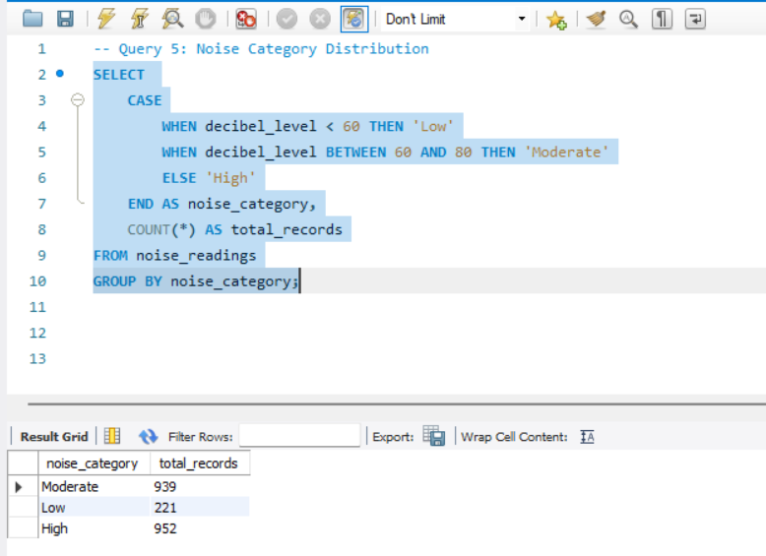

**-- Query 6: Hourly Noise Pattern**

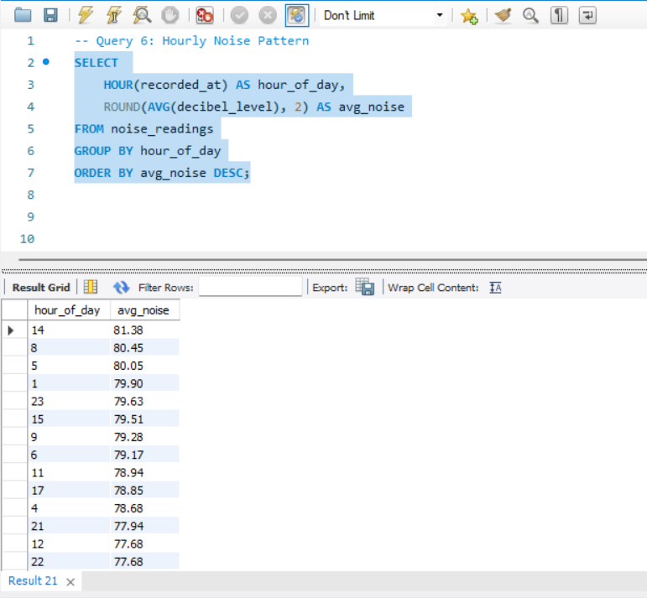

**-- Query 7: Event Day vs Normal Day Noise**

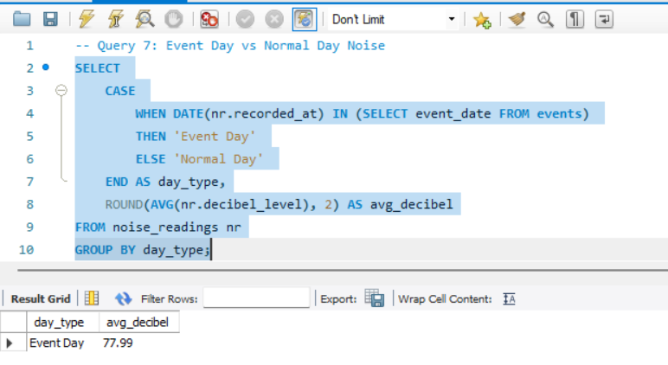

**-- Query 8: Avg Noise by Event Type**

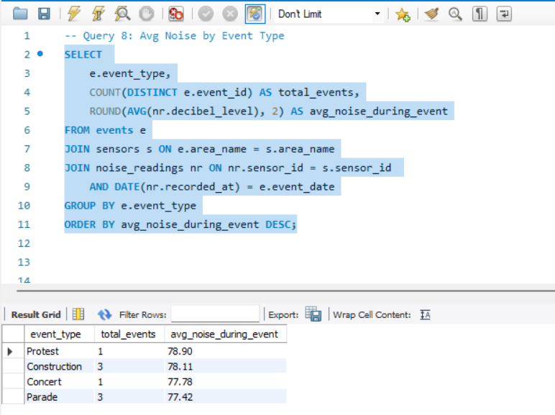

**-- Query 9: Areas with Unsafe Noise Levels (>85 dB)**

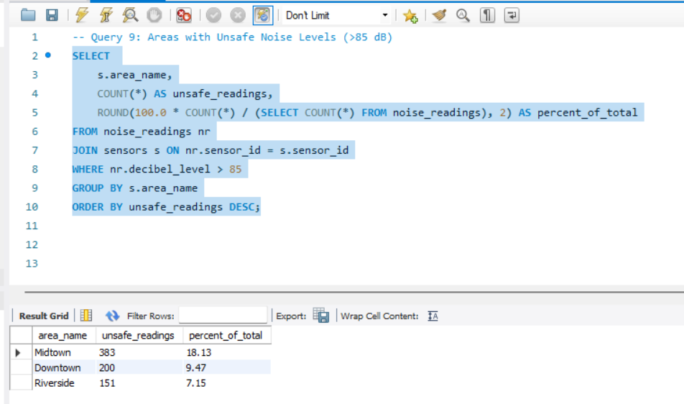

**-- Query 10: Daytime vs Nighttime Noise by Area**

